TrainOps Help/Manual
Contents
Introduction 3
Installing TrainOps 4
Updating the Program 9
Tutorial 10
Set up your railroad. 10
Overview 10
Preferences 11
The Main Screen 14
Defining Car Types 14
Adding your Cars 15
Locomotives 17
Caboose 19
Physical Layout 20
Trains 32
Running Trains 36
Printing Reports 36
Reference 38
Concepts 38
Off-Layout 38
Yards 38
Interchange 38
Industry Demand and Supply 38
File 40
Preferences 40
Configure 42
Physical Layout 42
Location 42
Sidings 42
Industries 43
Car Types 46
Commodities 47
Cars 47
Locomotives 49
Caboose 50
Trains 51
Run Trains 54
Terminating a Train 56
Reports 58
Car Location - All 58
Car Location Sorted – All 59
Equipment Location 60

Introduction
TrainOps is a switch list generator designed for outdoor large scale railroads. Outdoor railroads have different operating requirements than indoor railroads. Cars are typically brought inside between operating sessions. Many large scale railroads do not have the volume of rolling stock that indoor railroader possess.
TrainOps was designed to be simple, so it may not possess all the bells and whistles that other railroad programs provide. However, it is simple to set up and get trains running.
TrainOps provides:
- An easy to setup and modify logical view of your layout, including all of your sidings, locations and industries.
- Supply and demand for each industry based on car type and subject to your own wishes. You can decide how often cars are delivered to or shipped from each industry.
- The ability to have foreign road cars enter and exit your layout via interchange tracks.
- Switch lists for each train to be run in an operating session
- A set up list that details the location of each car at the start of an operating session
- Train orders based upon industry, locations, or trains.

Installing TrainOps
Double click on the setup file (TrainOps_setup.exe) to start the installation process.

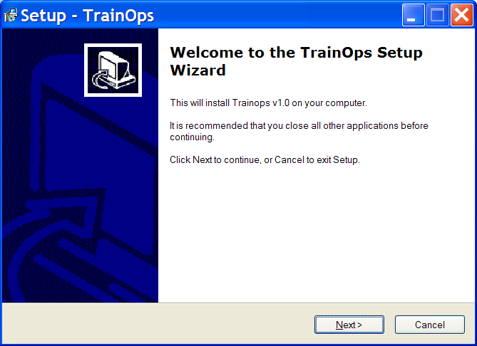
Click next.
On the next screen, you can change the installation directory, or you can let it default.
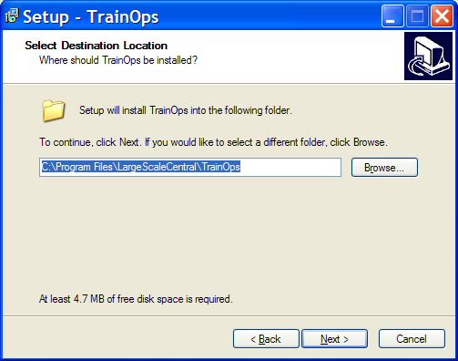
Then click next.
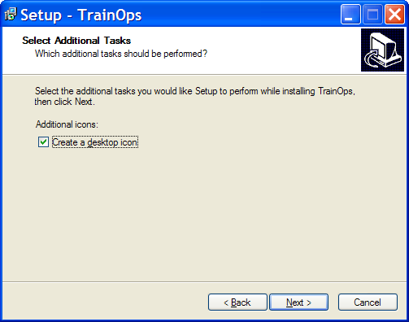
If you’d like an icon on your desktop, you can leave the option checked, otherwise you can uncheck.
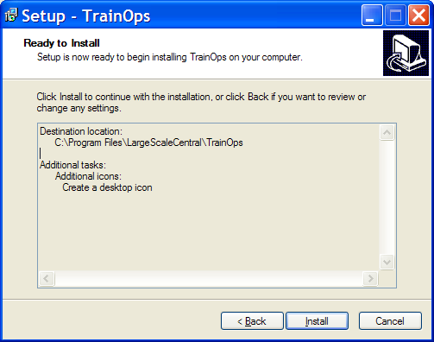
This is your last chance to change your mind. I just clicked on install.
You’ll see a progress bar. When it is complete, you’ll see the following screen.

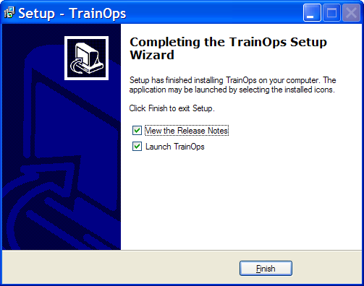
After the install is completed you just click on the Finish button.
A text window will open displaying the latest release notes, and TrainOps will launch.
You’ll see an about window:
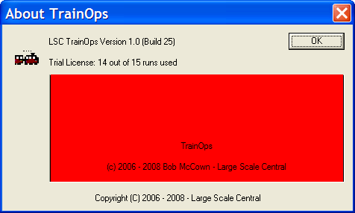
You can click OK, and the program will build the initial database. Once complete, it will open a Preferences and Defaults window. Take the time to at least read through the tutorial so you can see how to set up your railroad.

Updating the Program
If you’re connected to the internet, then whenever you start TrainOps, it will check to see if new updates are available.
If changes have been made, you will see this screen:
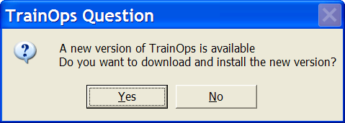
Click yes to get the new updates, otherwise you’ll have the chance next time.
TrainOps will install a new executable, as shown in the Installing TrainOps section on page 4.
You may also see that database changes were made.
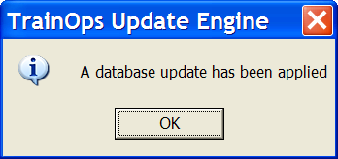

Tutorial

Set up your railroad.
Wow, you’ve just bought this neat new operations program and you’re dying to get started. This part of the guide is to help you get up and running. Later, you can get additional details in the reference section. You might want to have this document visible while you’re running TrainOps.
First things, first; don’t start TrainOps. Get out a tape measure and go measure each of your sidings. We want to know the total length of the siding. Don’t measure from the switch, but from the point where a car can get by on the diverging track. TrainOps will need this information to calculate how many cars can be stored on each siding.
You might also want to measure each one of your rolling stock. You can set an overall default, but if you have a lot of variety in your inventory, it might be better to measure individually. TrainOps uses this information to determine how many cars can fit on each siding.
While you’re measuring, this is a good time to write down your inventory. You’re going to need to know the reporting marks and the car number for each piece of your rolling stock.
OK. Now that you’ve got all of that information it’s time to start TrainOps.
Double click on the TrainOps icon. The program will start.

Overview
You should now be looking at a blank screen. Well, not quite blank. There’s a menu bar across the top and this is where we will perform all of our actions.
In short, here’s the organization:
- File
  - Preferences
  - Exit
- Configure
  - Physical Layout
  - Car Types
  - Commodities
  - Cars
  - Locomotives
  - Caboose
  - Trains
- Run Trains
  - Run
- Reports
  - Car Location Reports
    - Car Location – All
    - Car Location - Trains
- Help
  - Help Topics
  - About TrainOps
We’re going to go through most of these as we set up. It’s a bit of work at first, but after you get everything set up, you’ll typically just run trains and print reports in future sessions.

Preferences
When the program first starts, a window will open allowing you to enter your preferences.
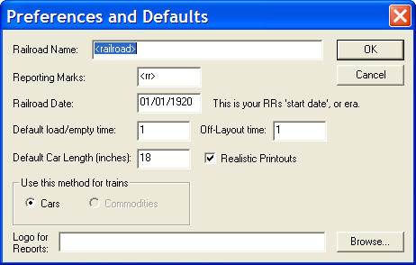
You’ll want to enter at least your Railroad Name and date, but you can let everything else default for now. Later, you may want to experiment with the realistic/non realistic reports option. It’s easy enough to do; just come here and check or uncheck, and the report format will change for the next report you run.

Simplistic Switch List
The simplistic Switch List gives basic directions for running a specific train. You get it by unchecking the Realistic Printouts box.
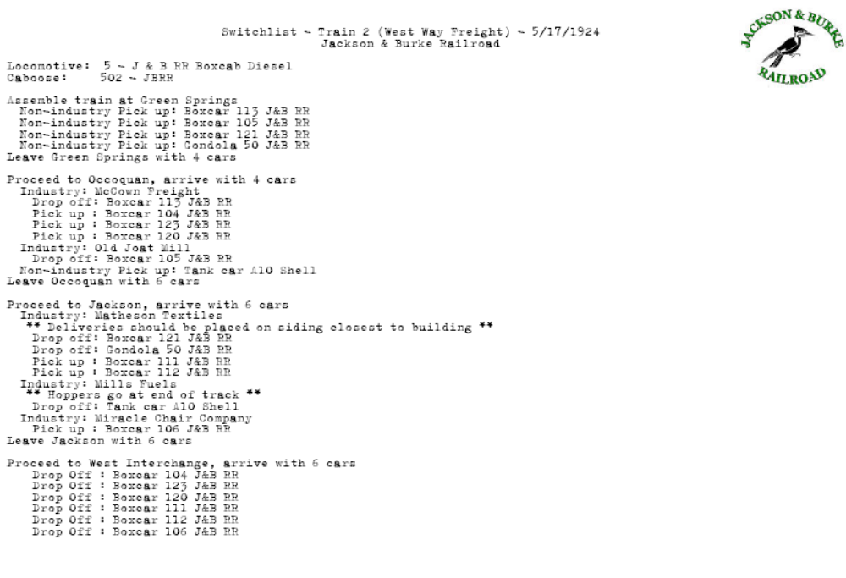

Realistic Switch List
This switch list is based on a prototypical example. Check the “Realistic Printouts” to use this type of list.

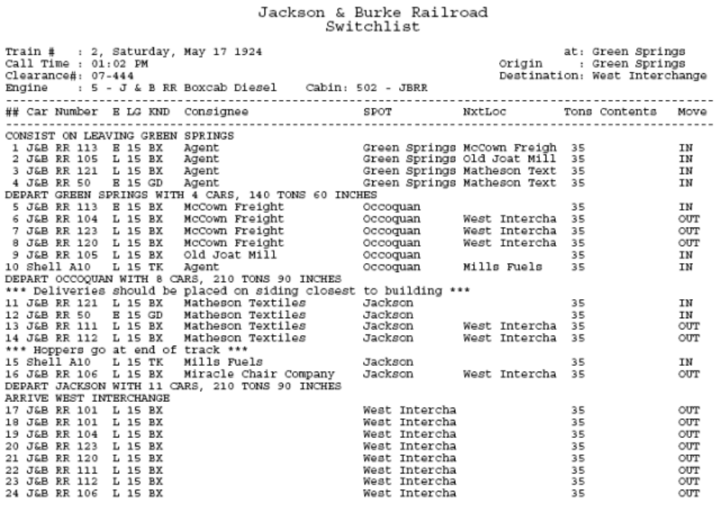
You can also add a logo that will print on the simplistic switch list, but for now, we’ll just hit OK.
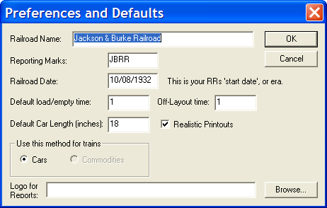

The Main Screen
You are now at the main screen for TrainOps.
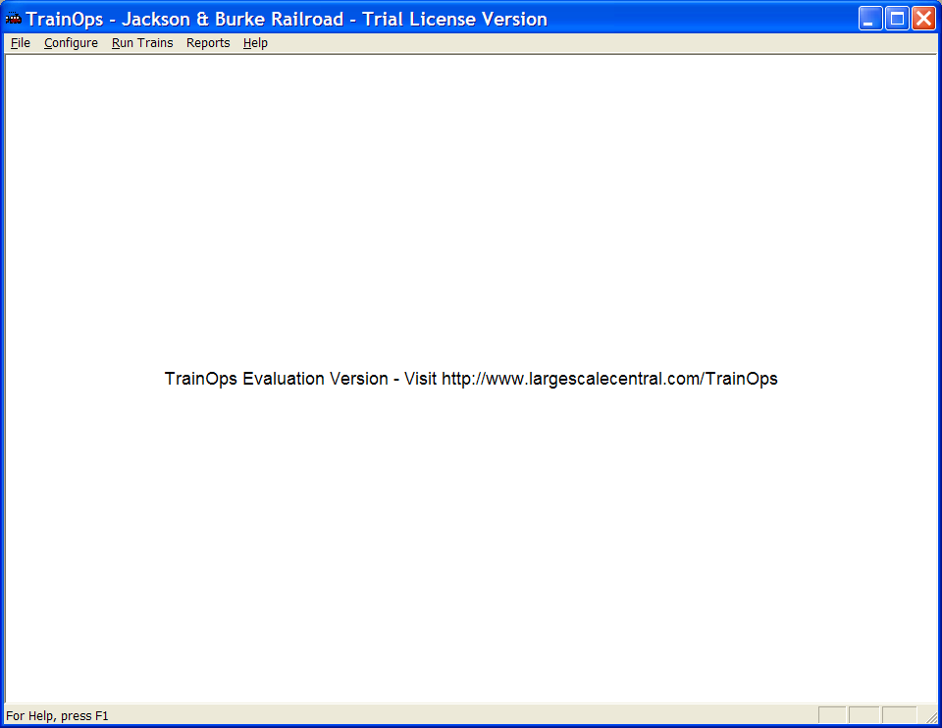
This shows that you are running the trial license version. Once you license it, it will remove that from the screen as well as give you the clean printout without Evaluation Version on it.
Notice that your choices run across the top of the screen. Right now, let’s choose the Configure option from the menu.
First, we’ll define the types of cars that you own.

Defining Car Types
TrainOps needs to know what types of cars you have on your layout. There’s no sense in having types that you won’t be using. Or, perhaps you have a car type not listed in the default. Look over your inventory and see what types you have. This is also your chance to decide how specific you want to be. For instance, you can track just hoppers, or define two-bay, three-bay, or covered hoppers. Later, we’ll use these types to determine which cars service the different industries on your layout.
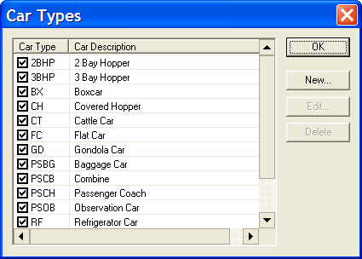
At this point, it’s probably safe to just use the defaults.

Adding your Cars
When you select “Cars” from the “Configure Menu” you see the list of all your cars, categorized by car types.
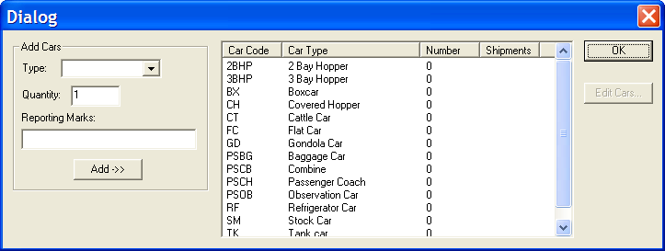
Right now, you have not entered anything, so it’s time to enter your cars. I find it easier to add all of one type of car. For instance, I’ll select the cars menu, and then from that dialog select the type Boxcar and type in a quantity of 15. 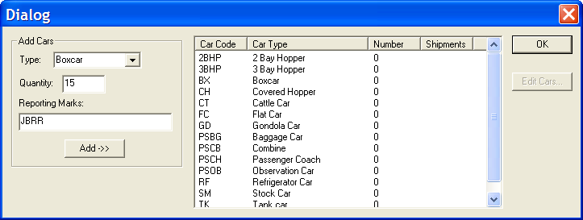
I’ll enter the most common reporting marks and then press the “Add->>” button. This will add 15 boxcars to the inventory. The screen below shows 15 boxcars are now entered.
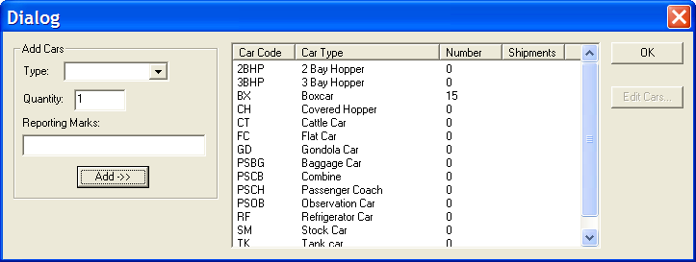
Next, I’ll select boxcars and press the “Edit Cars” button. (Double-clicking on the boxcars also works.)
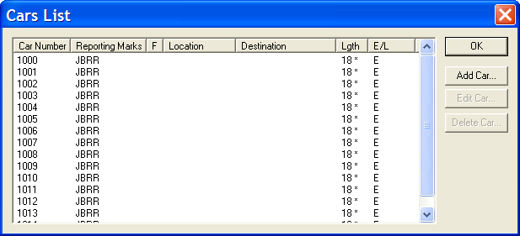
Now, I’ll edit each car, as those 15 boxcars will have been automatically numbered from 1000 to 1014. This will give me a chance to change name, reporting marks and car length.
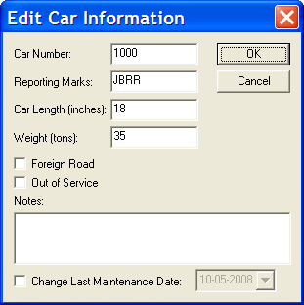
If the cars belong to another railroad (not the home railroad), then you can mark them as “Foreign Road” cars. These cars will only enter and exit your layout at a track identified as an interchange track.

Locomotives
As long as were rolling along, we might as well enter all of our locomotives. Select “Locomotives” from the “Configure” menu option.
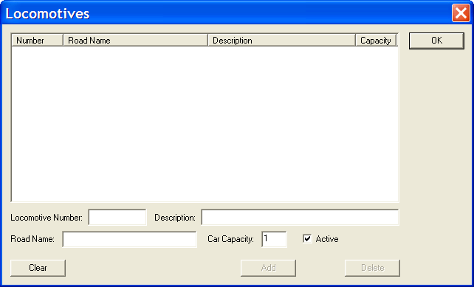
Enter the appropriate information at the bottom of the screen.
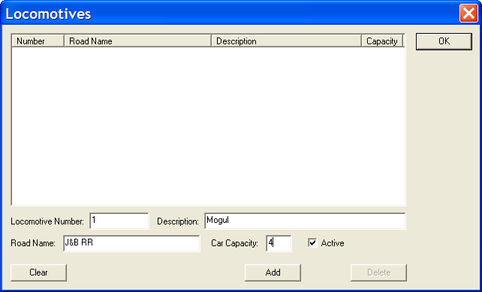
The key here is to decide how many cars each locomotive can pull. This is up to you to decide. This capacity only includes freight cars, not the caboose. Once complete, just press the “Add” button.
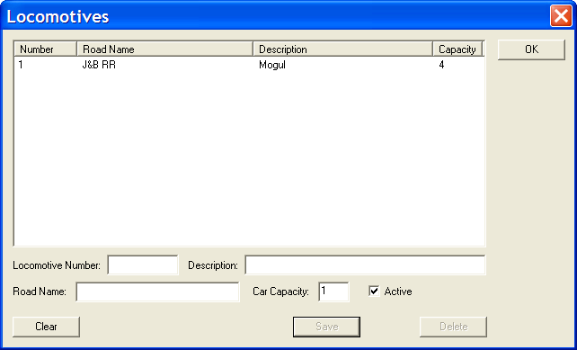
You can enter all of your locomotives, but for now, I’ll just enter the one.

Caboose
Finally, let’s enter our cabooses. There’s nothing magical here, later we’ll choose which caboose goes on the day’s run. Choose “Caboose” from the “Configure” menu option to get this screen:
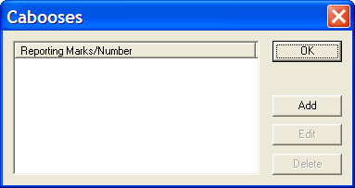
Press the “Add” button.
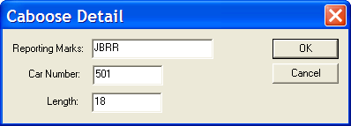
Complete the necessary information, and press “OK”.

Physical Layout
You’ve entered your cars, locomotives, and cabooses. Now it’s time to tell TrainOps about your layout.
Your railroad is a hierarchy consisting of locations which contain sidings which contain industries. A location can be a town, or it can just be a place on your railroad where you have a spur that serves an industry. It’s completely up to you – and you can change your mind later!
The key in this section is to have names for everything: for your locations, your sidings, and your industries. But, don’t get too hung up on trying to come up with a name for that obscure siding; everything can be changed later as you wish.
The physical layout is how your railroad is defined. It may make more sense to you to put all of the sidings in a town in alphabetical order, or maybe by length of siding; or some other way that makes sense to you. Notice that when you select a defined siding in a town, you can move it up or down in the display order – so you can arrange them just the way you want.
You can enter all of your locations first, or add a location and then enter all of your sidings and then your industries. It’s up to you.
Let’s walk through the process. Select “Physical Layout” from the “Configure” menu option.
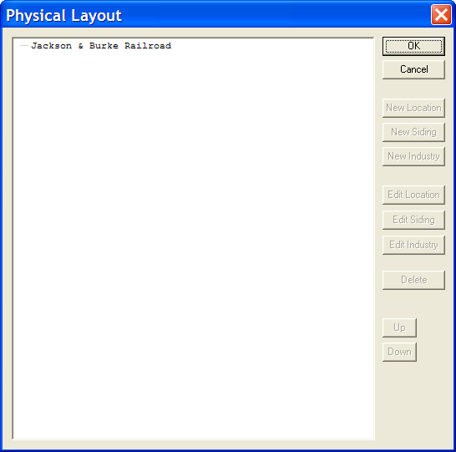
There’s nothing there yet, except for our railroad name that we entered in “Preferences”.
Select that name and “New Location” becomes selectable.
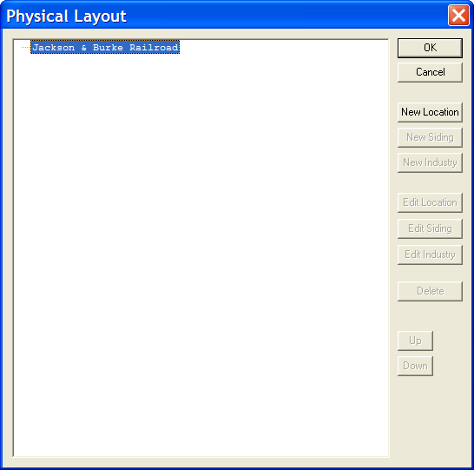
Press the New Location and you’ll get the next screen.
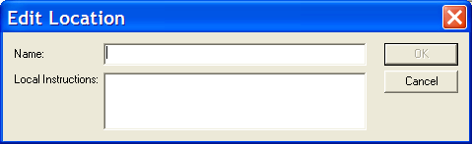
Enter the name you want to call it. There’s no need to enter any Local Instructions right now, but that is a place where you can put in specific directions for the engineer switching this location.
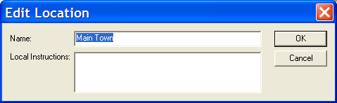
Once you enter the data, press the OK button.
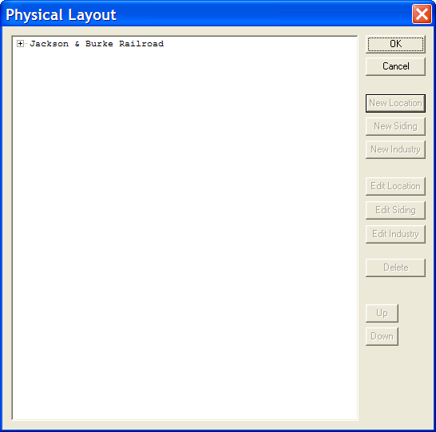
You’ll see that your railroad name has a “Plus” box in front of it, indicating that there is something there. Click on the box to expand it.
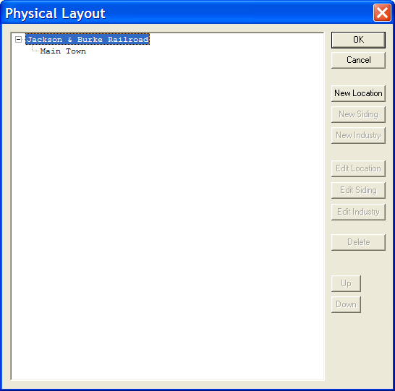
Go ahead and add one more town.
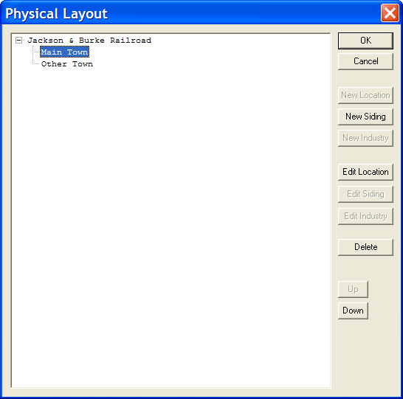
Notice that when you select a location, other buttons become enabled. You can now select the “Edit Location” button if you want to go back and change the name, or add some local instructions. Right now, we’re going to add a siding, so click on the “New Siding” button.
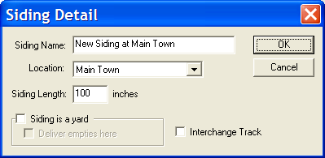
Now you can name the siding, or just leave it as it is. If you meant to add this to a different location, you can use the drop down in “Location” to select from any of the locations that you have defined.
Siding length is used to calculate how many cars can actually fit on this siding.
Besides being a place for industries, sidings can serve other functions. They can act as a yard track. This is a place for TrainOps to bring cars from off-layout to supply your industries. It can also be a place to deliver extra empties. Or, if you want to bring on foreign road cars, you can use the “Interchange Track” option to enable traffic to this siding.
We’re going to have 3 sidings in Main Town. They are all yard tracks.
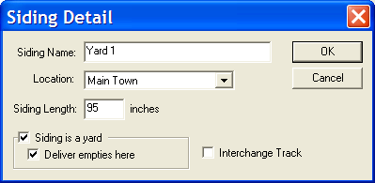
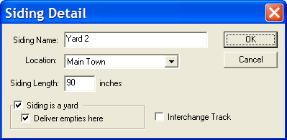
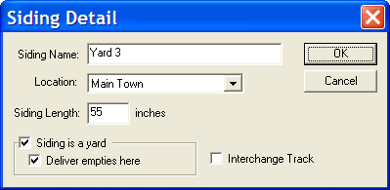
The yard tracks will be designated as a place to send empties.
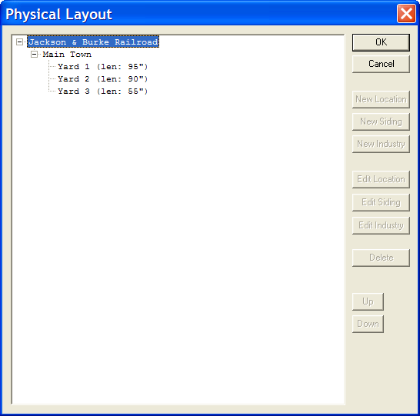
Now, let’s add another location called “Other Town”. Go ahead and add two sidings: one will be called “Milled Siding”, the other “Factory Siding”.
When you’re done, it should look like this:
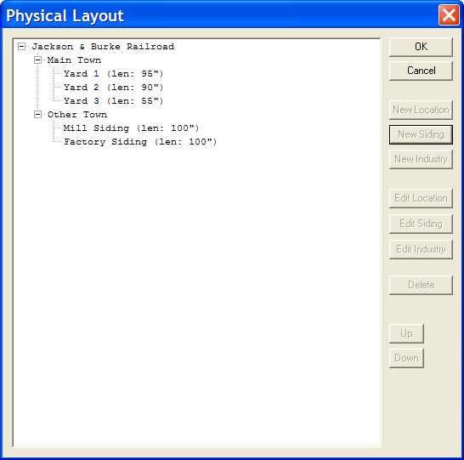
On the “Mill Siding” we’re going to add “Ye Olde Mill”.
Select “Mill Siding” and press the “New Industry” button.
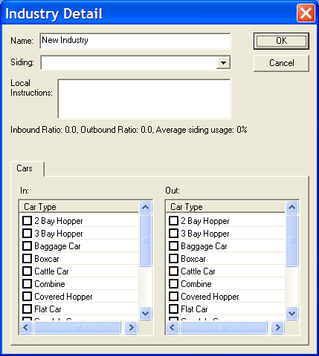
There’s a lot on this screen. At the top, is the industry name; pretty self explanatory. We’ll chance that to “Ye Olde Mill”.
Below that, is a drop down box where you can choose the siding and below that is a place for any local instructions that might pertain to the industry.
Finally, we have two boxes. One if for cars shipped IN, and the other is for cars shipped OUT. Think of IN cars as loaded cars delivering raw materials to your industry. Think of OUT cars as ones that have been loaded with the finished product that your industry produces.
Probably the hardest part of TrainOps is setting up the industries. This is because you’re going to want to generate some realistic traffic. You will have to think about the types of raw materials that a factory might need and what type of cars they might require. The same is true for finished products that will be shipped out.
To help you out, there’s some information just below the Local Instructions. This information tells you the average number of cars IN and OUT. Then it uses that average to calculate the siding usage. It’s all zero right now because we haven’t entered anything.
Let’s generate some boxcar traffic IN. Click on the box just in front of “Boxcar” in the IN list.
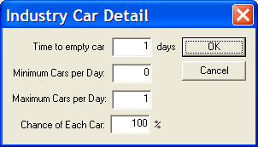
This screen allows you to set up the number of boxcars that will be coming IN to an industry. It will take some time to unload the car. The default is one day, but you can make it longer.
You can specify a range of cars from zero to some maximum. You probably do not want your maximum to be the capacity of your siding, as this will not allow for any other traffic. The default is to give you 1 car per day. Let’s change it to a range. We want a minimum of one car, but a 50% chance of a second car.
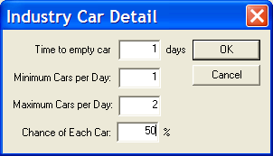
Press OK when done.
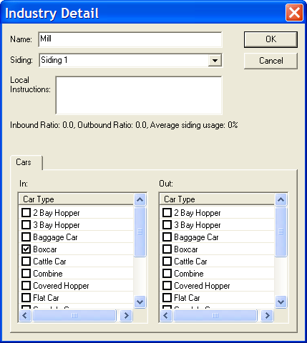
Notice that the Boxcar is checked in the IN box. Now, let’s check the boxcar in the Out column. We’re going to set the OUT boxcar traffic a bit different. A minimum of 1 car each day, but it can be up to 3 cars, with a 50% chance of car #2, and a 50% chance of car #3.
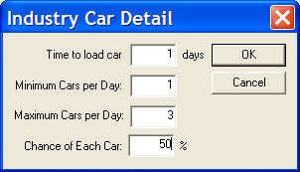
It’s probably going to take some fine tuning to get your traffic to the level that you want. Go ahead and set up a couple of sidings and two industries in the Other Town.
When you’re done, it should look like this:
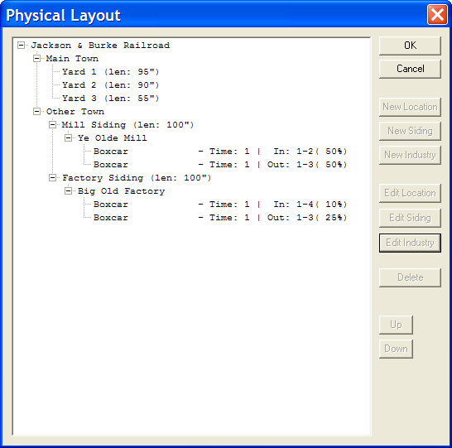

Trains
Defining a train consists of
- Setting up a route – start at location A, go to location B, finish at location C.
- Determining what industries will be switched at each location. This is your opportunity to create the type of train you want. It can switch only sidings with trailing points, or it might skip a town between two locations. It’s completely up to you.
Let’s start by selecting “Trains” from the “Configure” menu option.
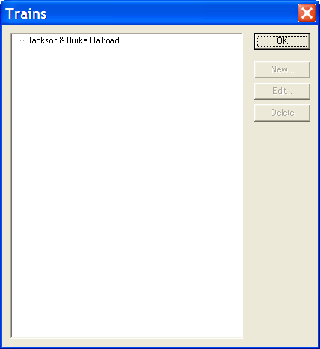
Of course, there’s nothing there yet. Select your railroad and press the “New…” button.
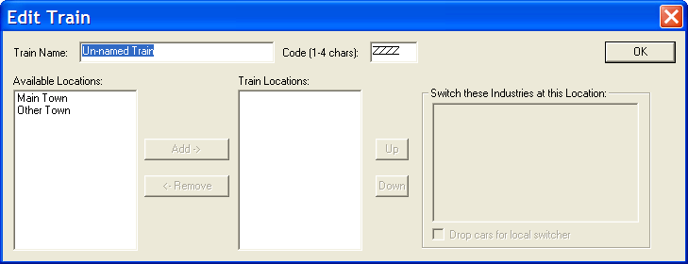
We’ll give this train a name and a number. This is just an easy way for you to reference your trains, plus this information will show up on your switch lists.
Next, we’ll select the locations we want the train to go to. In this case, we’re going to define a train that goes from Main Town to Other Town. Select “Main Town” from the left hand box and press the “Add button”.
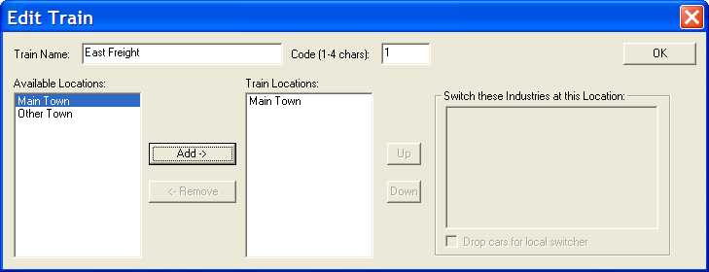
The center box contains the route. Go ahead and add “Other Town”.
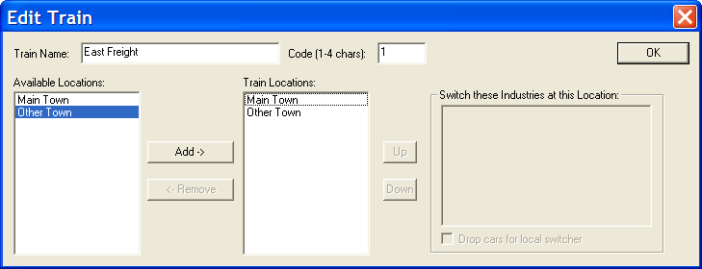
We’ve now defined a train that goes from Main Town to Other town. But, we haven’t told it what to do in each town.
Main Town is just our yard, so we don’t need to do anything here.
Click on “Other Town” in the middle box.
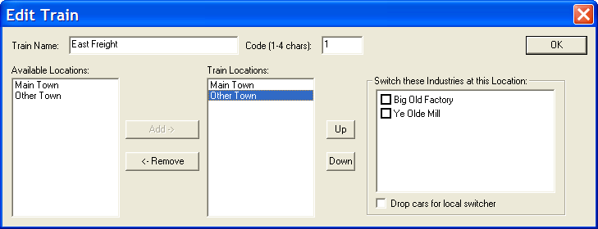
We’ll choose both of these industries to be switched. Choosing the industries to switch in each town allows you to fine tune each train. Later, you might want to allow a way freight to only switch trailing point switches because you want an easier run. Or, you might enjoy that challenge. It is completely up to you.
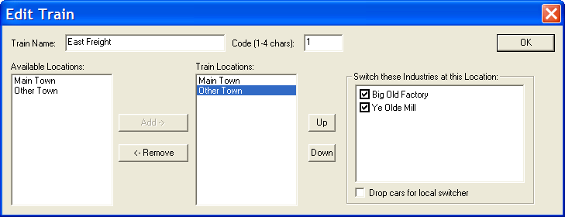
Then, click on the “OK” button.
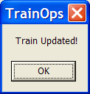

Running Trains
You’re ready! Now you can run a train for your operating session.
Choose “Run Trains” then “Run” from the main menu bar.
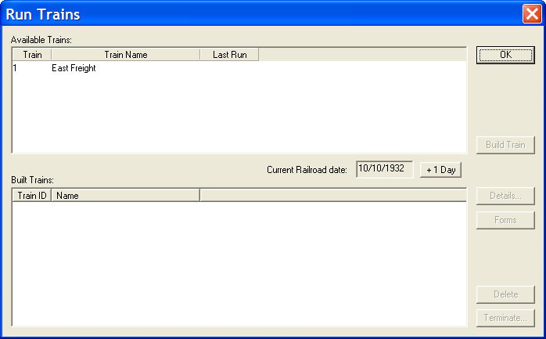
There’s the train we worked on. Select it, and press the “Build Train” button.

Even though you have only defined boxcars for your car type, there’s enough work to do.
Now that I’ve got my layout setup the way I want, this is where I start whenever I run train ops. You will only have to go back to the configure section if you acquire some new cars or locomotives, or if you add a new siding.
Check the Reference section (page 54) for the details on building a train.

Printing Reports
The one report that you’ll want to run is the “Car Location Report” – “Car Location – All”. This will tell you where to put each car for the operating session. Print that out so you can take it outside for setup.
If you didn’t print your switch lists when you built a train, you can go back to the “Run Trains” menu, select the train, and press the “Forms” button. This will open the viewer to show you the switch list created earlier. If you entered any local instructions it will also display train orders.
When you are printing, make sure that “Page Scaling” is set to “Fit to printable area”, otherwise the lines will be truncated.
Now, go operate!
Once you’re done, increment the day and build another train. See what changes. You may want to go back to the configure section to fine tune traffic details, or maybe add some train orders for an industry.

Reference

Concepts
TrainOps was originally designed to move cars around your layout in a prototypical fashion. It generates supply and demand via IN and OUT specifications by Industry. These specifications can have a degree of randomization set up so that you don’t have the same moves each operations session.

Off-Layout
Since a lot of us like to think that our backyard is only a small portion of a real (or imaginary) railroad, we introduced the concept of “off-layout”. We didn’t want to always operate with the same cars each and every session, so we decided that cars could disappear for a period of time and not be available for that operation session. It’s assumed that the cars going off-layout are going someplace that magically needs or has whatever our modeled industries need or supply. ANY car will go off layout after they've been used. (As either a load to be emptied, or empty to be filled). They get taken off-layout for a while. This way you get to operate with different cars each session and you have the ability to utilize many different car types.

Yards
Yards are tracks that are used to deliver empty cars to, if so designated. They are also a place where “off-layout” cars can enter or leave your layout. When a train is being built, TrainOps will note that a particular industry on the train route will require a car, either loaded or empty. If there isn’t one available on the route, TrainOps will choose a car from “off-layout”, designate it as a load or empty, and place it at a yard location before the industry that needs the car.
Note that if there are not any yard tracks on your layout, cars will never go off layout.

Interchange
Interchange tracks are places on your layout where you will exchange cars with other railroads. These cars are designated as “Foreign Road” when you set up your car lists. Foreign Road cars are always considered loaded and always enter your layout on the designated Interchange siding. Once they have been delivered to their industry, they will be unloaded and then moved to the interchange track from which they entered the layout.
Note that if you do not have any “Foreign Road” cars, you will not need to set up any tracks as an Interchange. If you do not set up foreign road cars then they will be just be pooled with your own railroad cars.

Industry Demand and Supply
TrainOps uses the concept of IN and OUT requirements for each industry. These requirements are for loaded cars. Loaded cars come IN to your industry. Loaded cars are shipped OUT from your industry. You do not need to ever specify a need for empty cars; TrainOps knows that you will need an empty car if you have an OUT requirement. If a loaded car is brought IN to your industry, it will take a “day” to unload it and produce an empty. If an empty was delivered (because you need to fulfill an OUT requirement) it will take a “day” to load and be ready for shipment. (You can control the length of time to empty/load a car via preferences.)
You don’t need to match industries. Since every car will leave your layout for "off-layout" number of days, we assume that loads and empties are fulfilled somewhere "out there". If industry X needs full boxcars, and ships out full flatcars, here's how the cars will flow:
Boxcar comes in from off-layout via a yard track, marked as full, and dropped at Industry X. Flatcar comes from either off-layout, or on-layout, and dropped at Industry X. After the 'load/empty' of the car passes, Boxcar gets picked up (it’s now empty), and delivered to a yard (eventually the "drop empties here" yard), and taken off-layout. Flatcar (now full), will follow the same process: delivered to a yard, and taken off-layout.
The "Interchange/Foreign Road" flag is just a variation of this concept. If the car is not a car of your own RR, then it enters and leaves via an interchange siding, not a yard track.

File

Preferences
This is where you can customize TrainOps for your own railroad.
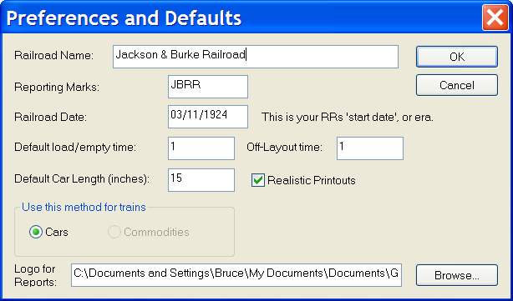
- Railroad Name: Enter the name of your railroad. This name will be used on the reports.
- Reporting Marks: Enter the reporting marks for your railroad. This will be used when you add new rolling stock.
- Railroad Date: Each time you run a session, this will be the date printed on switch lists and car reports. It gets incremented on the Run Trains dialog.
- Default load/empty time: This specifies how many “days” it takes to load or unload a car.
- Off-Layout Time: When a car goes off-layout, how many days will it take before it’s available. Many of us like to think that only a portion of the imaginary railroad has been modeled in our back yards or basement. Having a car go off the layout means that it will “disappear” from operations for awhile, just as if it had gone on to a non-modeled part of your railroad.
- Default Car Length (inches): Specify the most common length of your rolling stock in inches. This number is used to automatically enter a length when you add new cars, although you can change it to be the actual length of the car you add.
- Realistic Printouts: If this is checked, your switch lists will be based on the prototype. If unchecked, you will get a simpler switch list.
- Use this method for trains:
  - Cars: Traffic will be generated based upon car types.
  - Commodities: Traffic will be generated based upon the contents of cars. This is not yet implemented.
- Logo for Reports: You can add a graphic file (PNG or JPG) to be printed on your reports. The logo will not be displayed if you select “Realistic Printouts”. Press the browse button to locate this file on your computer.

Configure

Physical Layout
The physical layout screen is where you will define your railroad.
A railroad is made up of a hierarchical organization of locations, sidings, and industries.
A location can be a town or just a spot on the railroad where you will do some switching. Each location can have one or more sidings, and each siding can have one or more industries.

Location
To enter a new location, click on your railroad name in the window and press the button marked “New Location”.
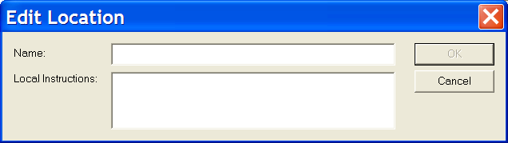
Enter the name of the location and provide any specific instructions for this town. The local instructions will appear on Form 19, general train order.

Sidings
Once you have a location, you can add one or more sidings to that location. Select a location, and press the button labeled “New Siding”.
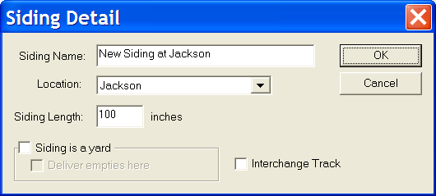
Provide the siding name. I typically name my sidings after the industry that will be located there, but you can name it anything you want. It’s purpose is to help you identify all of your sidings.
The location field has a drop down to allow you to change the location of this siding to any location that you have already defined.
Provide the siding length in inches. TrainOps uses this length to calculate how many cars can be put on a siding at any one time.
The “Siding is a yard” check box tells the program that this track will be a yard. This means that your rolling stock can enter or leave your layout at this point.
“Deliver empties here” will tell TrainOps that empties should come to this yard. While TrainOps will try to find an industry that needs an empty, you want a place for empties to go to, so they don’t stay on the industry sidings.
An Interchange track means that foreign road cars (cars that don’t belong to your railroad) will enter and leave at this siding.
Just like yard sidings, you can have as many interchange tracks as you like.

Industries
An industry is why you have the railroad in the first place. An industry will have supplies shipped in and products shipped out. It generates the traffic for your railroad. To create an industry, select the siding where you will locate it and press the “New Industry” button.
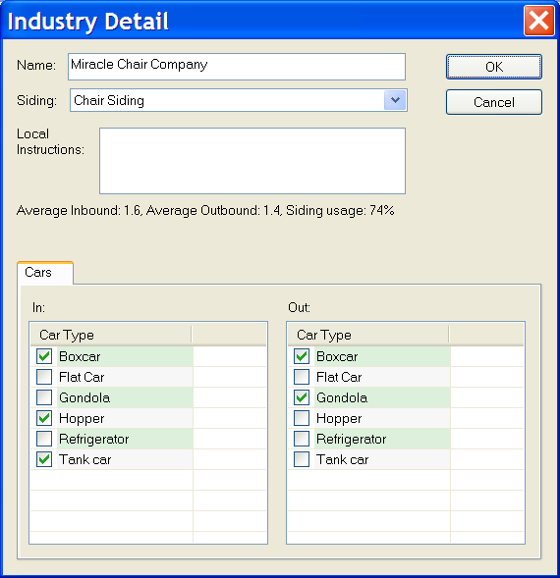
Provide a name for the industry. The drop down box allows you to select an already defined siding.
The Local Instructions field is used to provide some details to the operator that will be switching this industry. You might want to tell the operator to place new deliveries at a specific spot, or put a specific car type at the end of the track. When entering your data, you don’t want to end your text with a period, as the text will be appended with the words “at industryname” for industries. This is because at any one town you could possibly have notes for each industry, and all of the industry local instructions will be printed on one Form 19 per town.
Just below the instructions field is a summary of cars IN and cars OUT. These are averages based upon the range you have set up for each car. The two are totaled together to give you an average utilization based upon your siding length. You will want to make sure that your sidings are not over utilized.
Sometimes an industry may have multiple sidings that serve it. The best way to handle this is to define one siding. This siding will have a length that is equal to the sum of the lengths of those sidings. I usually round down the length, depending on my car length. Just because each siding can hold 3 ½ cars, doesn’t mean that your sidings together can hold 7 cars. In this case, I make the siding long enough to hold six cars.
In this example, I have selected “Cars” on the preferences manual as the means to generate traffic. Thus, it lists all of the car types you have defined.
Loaded cars come IN, and loaded cars go OUT. You may want to define different types of cars for each. For instance, many industries might have boxcars bringing raw material IN, and shipping finished product OUT. Or, an industry may generate scrap that they need a gondola to ship it OUT. IN and OUT cars are always considered as loaded cars. An IN becomes empty after the “Time to empty car” has passed. An empty will be required before an OUT car can be picked up.
You decide which type of car and which type of traffic by clicking on the check box in front of a car type under IN or OUT. This gives you a screen that allows you to specify details about each car type.
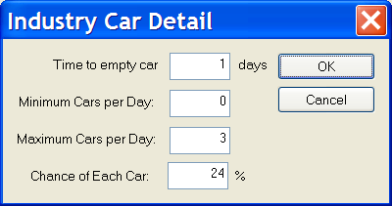
The “Time to empty car” allows you to specify how many “days” it will take to empty the car. This is from an IN box. If it was an OUT box, it would say “Time to load car”. The default is one day. You can make it longer if you desire. This controls how long it will stay on a siding at an industry until the program assumes it is ready to move.
The “Minimum Cars per Day” is the smallest number of cars that could show up. In this case, it is 0, which means that some days it may not receive any cars. The “Maximum Cars per Day” specifies the highest number of cars it can receive in a day. The percentage field gives you the odds of getting each car. In the case TrainOps will note that there is a chance of getting between zero and two cars each day. It will do a random check of 75% for car #1, and then 75% for car #2.
You can customize each industry to require specific car types and their odds of coming IN or going OUT.

Car Types
The car types menu item allows you to choose the car types that you want to have on your layout.
The defaults that are provided with the program includes lots of car types.
However, you can edit this list
However, you can edit this list to just list the car types that you possess.
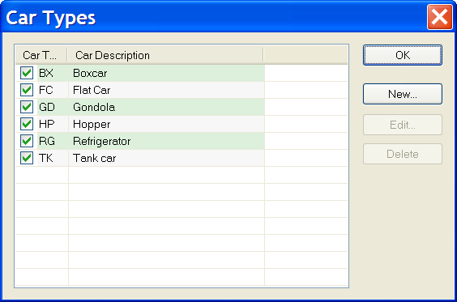
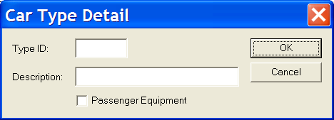
The “Type ID” field allows you to create a car type. This will show up on the realistic switch list. The description allows you to specify a longer word or two for this car type. The description will be used if you choose not to use the realistic switch list.
Passenger Equipment is used to indicate that this is not to be switched via the same mechanism as freight cars. Currently, TrainOps does not do anything with Passenger Equipment.

Commodities
Future.

Cars
This is the place that you can track all of your rolling stock and it is organized by car type.
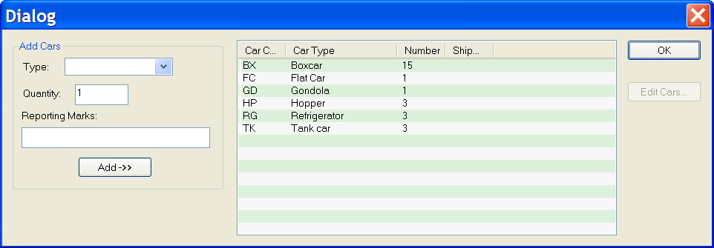
Only the car types that you have checked will be shown. The number of each car type is shown.
To add a new car or cars, select the car type from the drop down box on the left, key in a quantity and the Reporting Marks and press the Add button. It will add those cars to the list of active cars.
You can edit your existing cars by selecting the car type in the right hand side of the screen and pressing the “Edit Cars” button, or double-clicking on the car type.
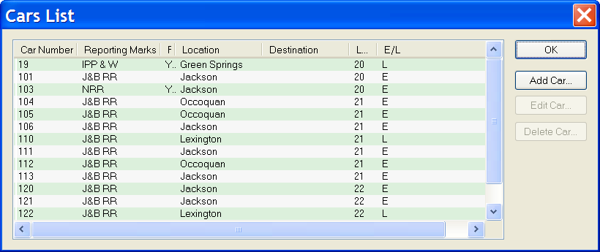
This screen shows the car number, the reporting marks, the current location of the car, and where it is headed. It shows the length and the status: empty or load (E or L). The * next to the length indicates that you have not edited this car yet.
The F column indicates that the car belongs to a foreign road.
To edit a car, select it and press the “Edit Car…” button, or double-click on the car number.
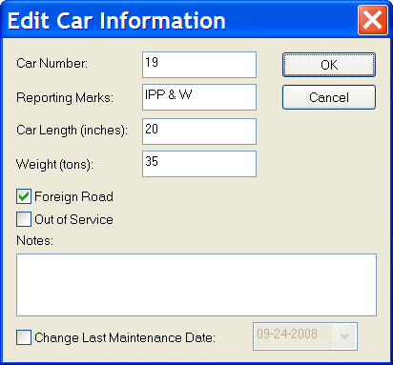
This allows you to change the basic information about the car. You will want to do this for each car you have added, as the default car number is 1000.
The checkmark in front of Foreign Road means that this car does not belong to your railroad.
You can take a car Out of Service by checking this box. This will not immediately move the car. It just means that the car will move to “Off Layout” as soon as possible.
The Notes field allows you to enter any information you would like about this car. It is free form.
Maintenance is very important to smooth operations. You can keep track of when you last did any work on the car by checking the box. This will allow you to change the date for last maintenance. If you have never done any maintenance on this car, the date shown will be today’s date.

Locomotives
You need locomotives to pull your trains and you define them here.
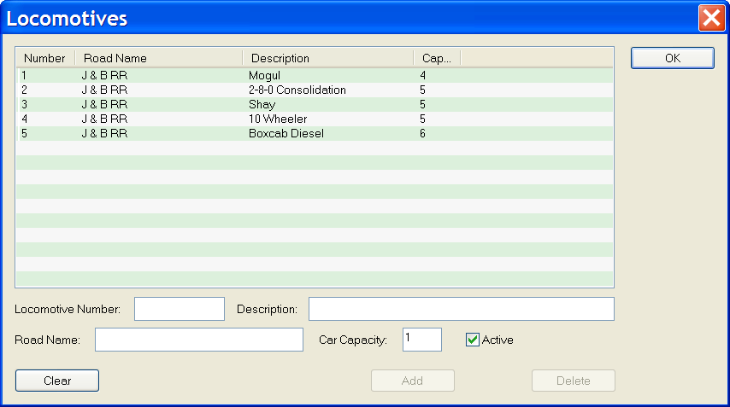
Enter the Locomotive number, a brief description, road name, and car capacity. The car capacity is the number of cars that a train can pull. TrainOps will try to limit the number of cars assigned to a train based upon the locomotive capacity.
The “Active” check box allows you to take a locomotive out of service by unchecking the box when a locomotive is selected.
To edit a locomotive, select the locomotive in the top part of the window. The Add button will be changed to Update. Make your changes, and then press the Update button.
To delete a locomotive, first select it, the press the delete button. The locomotive will be permanently removed from your inventory.

Caboose
A caboose is a special type of rolling stock and is tracked separately from your freight cars. To add a caboose to your inventory, select the caboose option from the Configure menu.
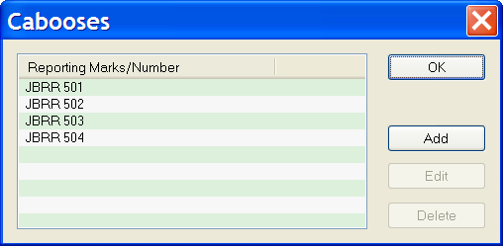
To add a caboose, press the “Add” button.
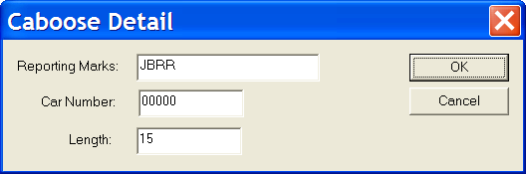
Enter the reporting marks, the car number and the length.
To edit a caboose, first select the caboose and press the “Edit” button. You can change any of the fields.

Trains
You will need to specify the number of trains that you want to run and the route of each train.
To define a train, select the “Trains” menu option from the main Configure menu.
Then, select your railroad and press the “New” button. This gets you to the Edit Train screen.
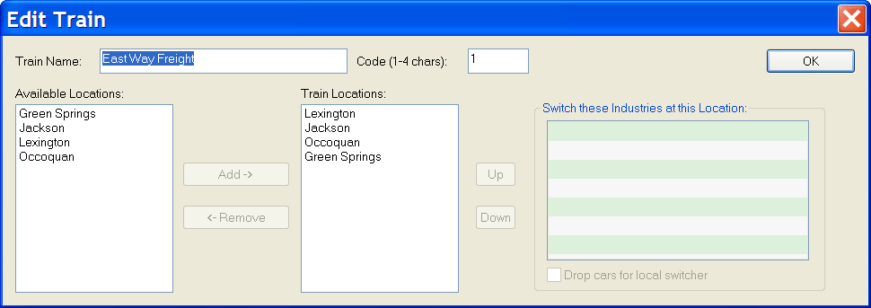
Enter a description for the train. This could be something mundane like “East Way Freight” or perhaps something esoteric like “City of New Orleans”. Put a number in the code field. Both of these fields will be displayed when it comes time to run trains, and it’s just a way to further identify them on your switch lists.
In the left hand box, you will see a list of the locations that you have defined. The right hand window contains the train locations in the order that you will switch them, in other words, this is your route.
To build the route, select the starting point from the “Available Locations” list and the press the “Add” button. To add another stop, repeat the process. You can rearrange your route, by selecting a location and pressing the “Up” or “Down” button to put that location in the right order.
When you select a location in the route, you will see the industries that are at that location in the right hand window.
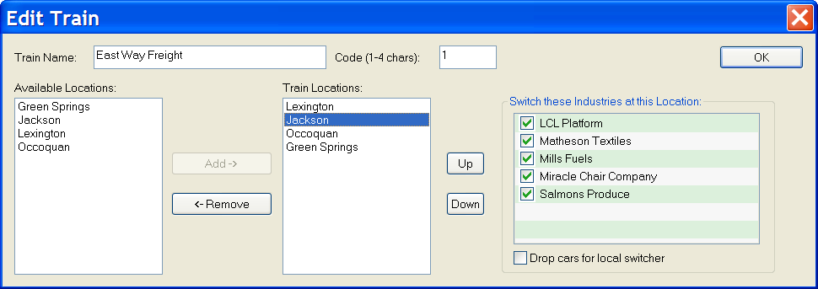
Check the ones that this particular train should switch. This allows you to set up a train that would only switch trailing points, for instance.
If you will just be delivering all those cars to a passing or yard siding at that town, you will probably want to check the “Drop cars for local switcher” option. In this case, my lowly way freight will switch all of the industries that are in the town of Jackson.
You can define as many trains as you like, and each train can switch all of the industries at all of the locations, or just some of the industries at only a few locations. You have complete flexibility to make the train do what you want it to.
Of course you may want to consider how long your trains and sidings are as well as how many cars each industry is generating in traffic supply and demand. It’s easy to fine tune this back at the edit industry screen.

Run Trains
Are you ready for an operating session? Then it’s time to Run Trains. Select this option from the main screen.
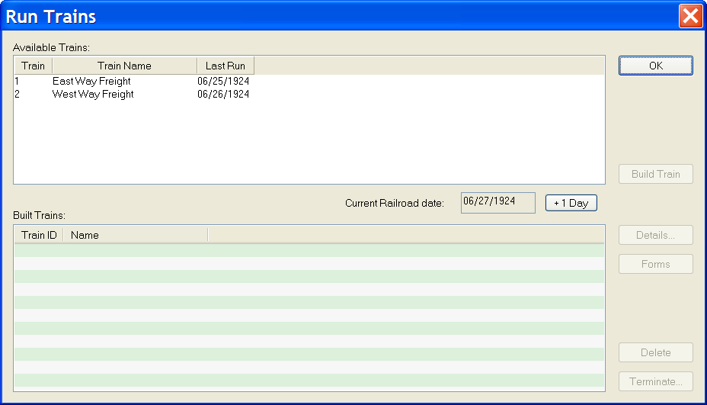
Here you see all of the trains you have defined. In this case, I have defined two trains. It shows the last run date of each train, and in the middle of the screen, the current railroad date.
To build a train, first highlight the train you want to build, and then press the “Build Train” button.
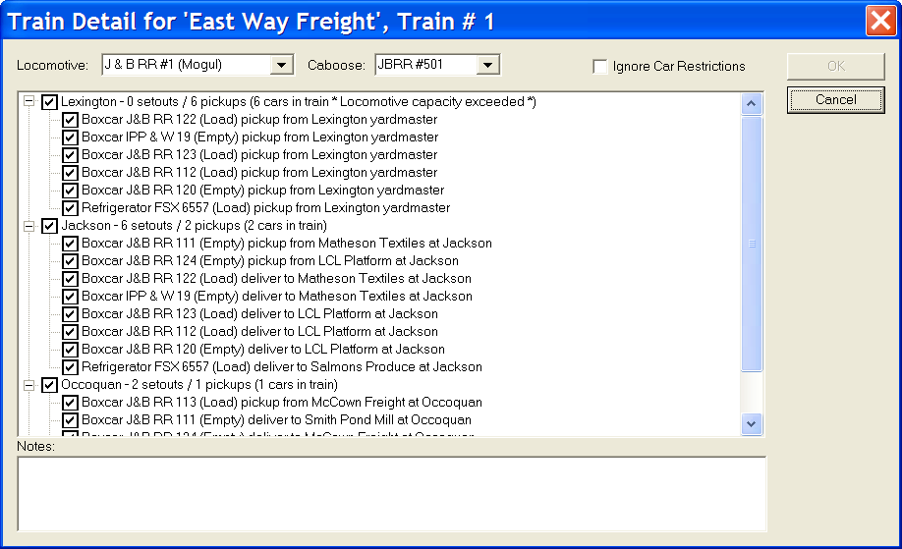
From the drop down lists at the top of the screen, you can select the specific locomotive and caboose that you want on the train.
For each location, TrainOps has picked a list of eligible cars. In this case, the list is too long, and my locomotive capacity has been exceeded. You can ignore this by checking the box “Ignore Car Restrictions”, or you can unselect a specific car to reduce the number of cars in the train.
The “OK” button will not be highlighted until I either check the “Ignore Car Restrictions” or reduce the setouts or pickups to meet the locomotive capacity.
The “Notes” field allows you to type in a specific train order, such as “Train #1 meet Train #2 at Occoquan”, or anything you like. If you type something in, a Form 19 will be generated.
Once you have the train the way you want it, press the OK button. TrainOps will open up an Adobe viewer and display your Form 19s, and your switch list.
Build as many trains as you would like for your operating session, but keep in mind that each train only runs once in a day. If you need more trains, you will have to define them from the configure menu.
When printing any of the reports, make sure that “Page Scaling” is set to “Fit to printable area”, otherwise the lines could be truncated.

When you’re done for the day, you can press the “+1 Day” button to advance the date. This will not only move to the next day, but will terminate any trains you have built. That means that TrainOps thinks that the cars in that train have been moved to the locations they were supposed to be. They will start at that new location in the next session. Advancing the date can also make cars get loaded or emptied, depending upon your load/unload times.
You can print the switch lists and form 19 train orders at any time by selecting a train and pressing the “Forms” button.

Terminating a Train
Terminating a train is a way to tell TrainOps that the train actually ran and performed the actions called for in the switch list.
Trains are automatically terminated, but you can also terminate a train manually.
You terminate a train from the “Run Trains” dialog. Select a train and press the “Terminate” button. You will see a list of all the cars that were picked up or delivered by the selected train. 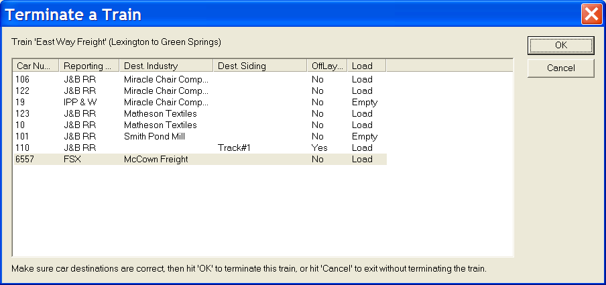
If you like, you can change the location of a car by selecting the current industry or siding. You’ll see a drop down box that allows you to select any siding on your layout. You can also change it to loaded or empty. The off layout column indicates that the car will be off layout for a period of time; this time is controlled via preferences. Naturally, you can change this as well.
Most of the time, I just click OK, since TrainOps will automatically track cars. So, why would you want to change anything? Well, if there was an operator error where a car was accidently delivered to the wrong siding, then this is a way to tell TrainOps what actually happened. TrainOps will attempt to route that car to the correct destination the next time a train is built.
Once you terminate a train, it will no longer be available to be run that day; you will have to increment the date before you can run that train again. The train will be highlighted in red until you increment the date.
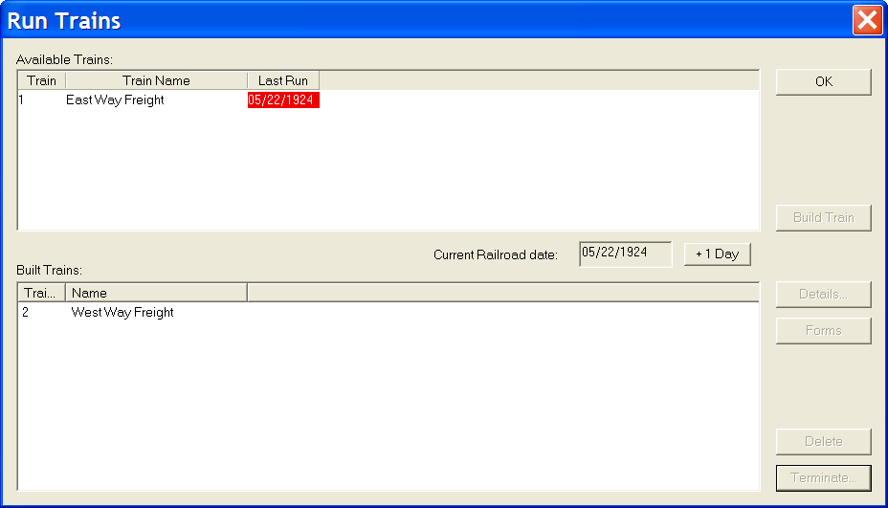

Reports
The report section provides a place to get printed reports about your layout. When printing, make sure that “Page Scaling” is set to “Fit to printable area”, otherwise some of the lines might be truncated.

Car Location - All
From the main menu Reports option, select “Car Location Reports” then “Car Location – All”.
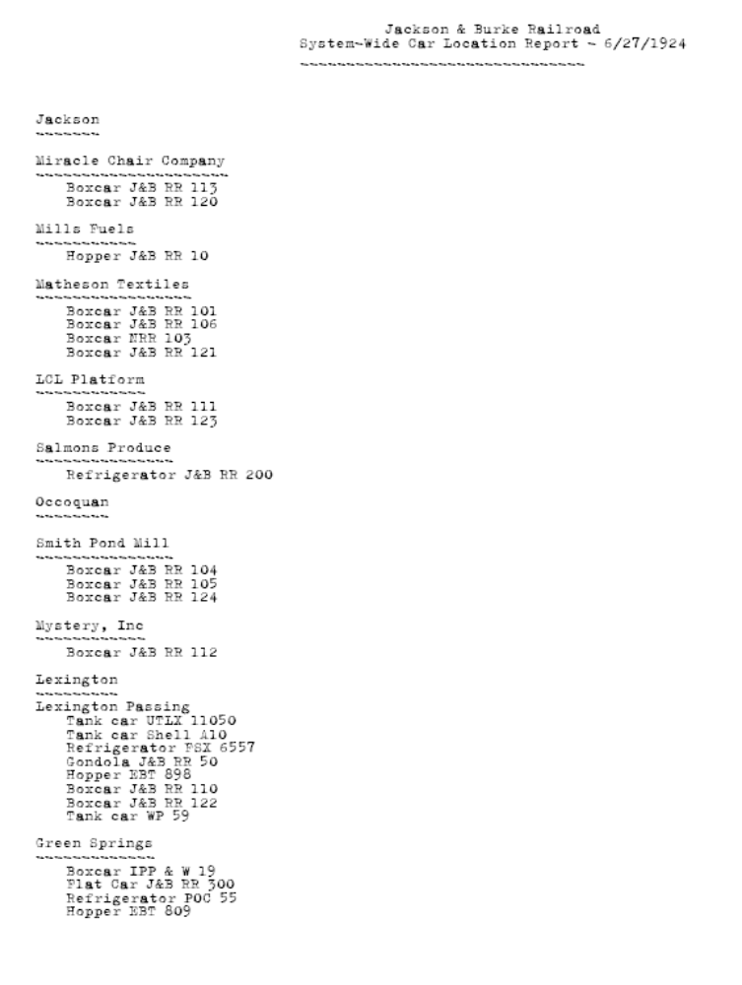
This report will tell you where to place all of the cars for your current operating session. It’s useful to check to make sure that all of your cars are positioned correctly before you start a session.

Car Location Sorted – All
This report shows your cars in sorted order. It makes it easy when you pick up a car and wonder where it goes.
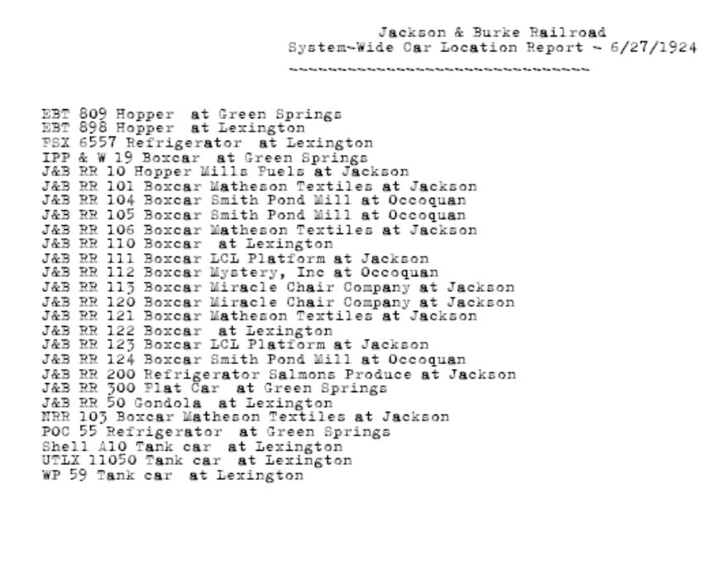

Equipment Location
The equipment location report is an interactive way to find out where all your cars are. Click on a location and all of the cars that are located there will be displayed.
Note that you can also view all of your cars that have moved off layout.

